Abstract

**Problem Discussion:** The primary objective of this project was to create a program for a public library management system using the computer language C++. Using this program, the librarian should be able to update library records by adding a new book or a new member. The user should also be able issue books by using issue a book option built in the program. Also, the user can have access to the list of books present in the library. This program would make it easy for the user to manage information regarding the library.

**To develop this program**, the software development life cycle process was implemented. This process consists of five different phases. First is the planning phase in which the entire project was planned. In the second phase which is the analysis phase, various charts such as problem analysis chart, etc. were made so that the members of the team would be aware of the problems to be solved for the successful completion of the project. The next step was to evaluate the design aspect of the program which would outline the working of the program. This came under the design phase. Various charts and diagrams such as the IPO chart, flowchart, CRC diagrams and use case diagrams were made during this phase. The algorithm and pseudocode required to write the actual program were also made during this phase. Now, it was time to write the actual code for the program which came under the implementation phase. During this phase, the code for the program was written and tested multiple times on Code Blocks. This process of writing, testing, and editing the code continued till a fully functional program was prepared. In the final phase, which is the maintenance phase, the fully functional program was tested again, and a training manual was created. (Paridhimathur95, 2021)

CRC (Class Responsibility Collaboration)

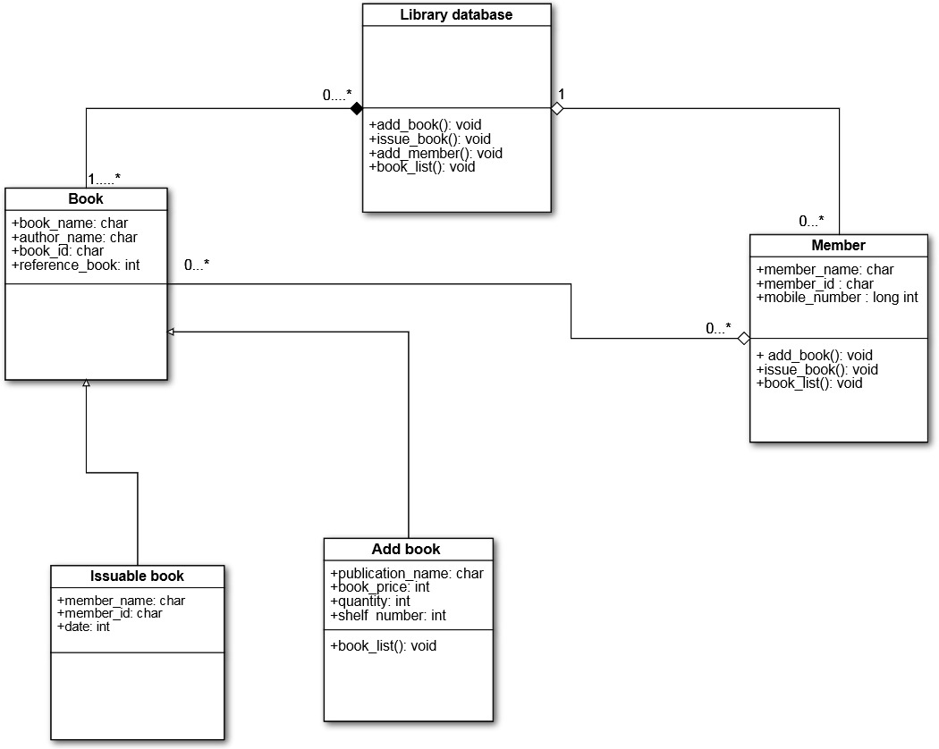

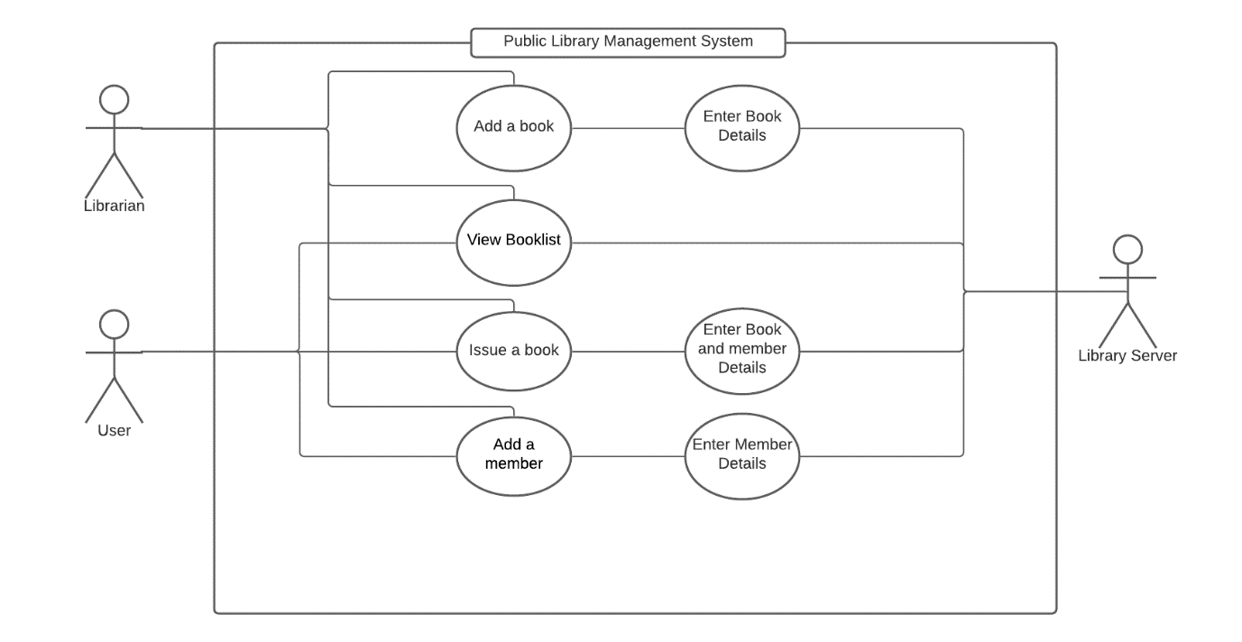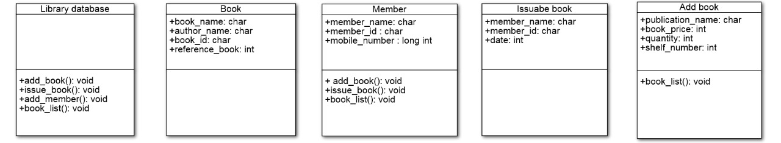

Class Diagram

Use Case Diagram

Problem Analysis Chart

|  |  |
| --- | --- |
| Given data | Required Result |
| Section 1:  To create a program for a Public library management system that gets data from keyboard or file for details of book and member. | Section 2:   1. Add books to booklist and view them. 2. Create new records of members. 3. Enable the user to issue a book. 4. Make reservations for reference books and books from same author. |
| Processing Required | Solution Alternatives |
| Section 3:   1. In a class named lib, create a main menu containing librarian function consisting of four switch cases. 2. Case 1: view booklist. 3. Case 2: enter the book details to add a new book. 4. Case 3: enter the book details and the member details to issue a book. 5. Case 4: enter new record of member. 6. Else go to main menu. | Section 4:   1. Give user the ability to view the booklist. 2. User can also add a new book by inputting the details for the book they require. 3. User can also issue a book by inputting their personal details and the details of the book they require. 4. User can also register as a new member in the library. 5. All the inputs mentioned above are taken either from the keyboard or the file. |

|  |  |  |  |
| --- | --- | --- | --- |
| Input | Process | Module Reference | Output |
| Booklist | Define a class named lib. | Define | View Booklist |
| Book details | Create a main menu that contains a function named librarian consisting of four switch cases. |  | Add a Book |
| Member details | In case one, a function named booklist is declared where the data is entered from an external file named Bookledger.txt. | Read | Issue a Book |
|  | Print booklist containing book records. | Print | Add a Member |
|  | In case two, if the user has to add New Book, he/she enters the book details else will be directed to the main menu. The new book record will be saved in an external file named Booksledger.txt. | Read |  |
|  | Print the record of new book added. | Print |  |
|  | In case three, if the user has to issue a book, he/she enters the book details and the member details and also chooses the book from the same author or the reference book, else will be directed to the main menu. | Read |  |
|  | Print the record of issued book and the member details. | Print |  |
|  | In case four, a new record of the member is registered and then the user is directed to the main menu. | Read |  |
|  | Print member details. | Print |  |
|  | If the user enters invalid input, he/she is directed to the main menu. |  |  |
|  | End |  |  |

IPO Chart

Interactivity Chart

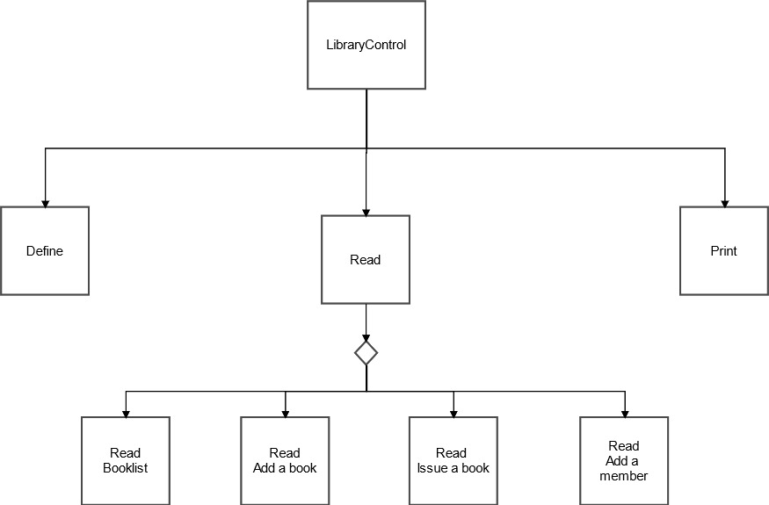

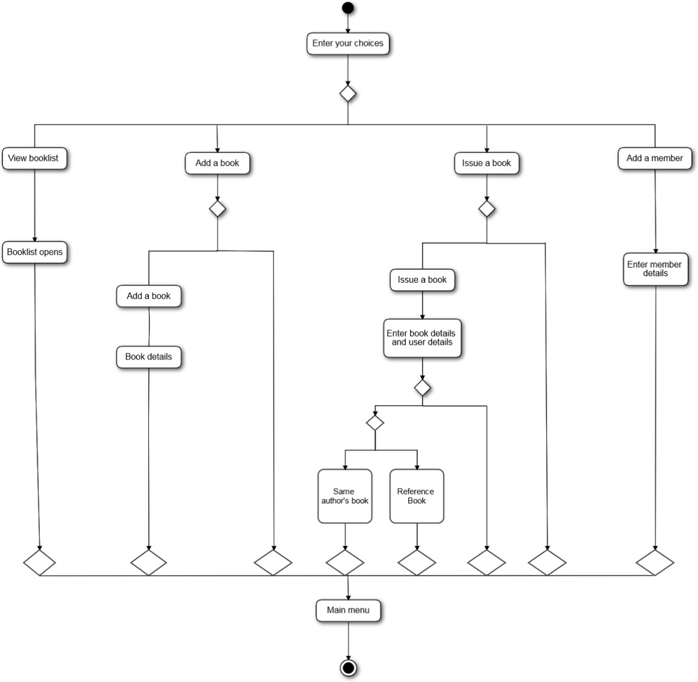Activity Diagram

Data Dictionary

|  |  |  |  |  |  |  |
| --- | --- | --- | --- | --- | --- | --- |
| **Item** | **Variable Name** | **Data Type** | **Module** | **Scope** | **Pseudonym /Module** | **Error check** |
| View Booklist | --- | --- | PRINT | --- | NONE | NONE |
| Add a Book | authorname  pubname  bookname  bookid  price  quantity  shelfno  referencebook | char[50]  char[50]  char[100]  char[20]  int  int  int  int | READ  PRINT | FORMAL  FORMAL  FORMAL  FORMAL  FORMAL  FORMAL  FORMAL  FORMAL | NONE | NONE |
| Issue Book | ch3  bookid  ch1  studentname  studentid  d  month  year  t  ch  authorname  bookname | int  char[20]  char[100]  char[100]  char[100]  int  int  int  int  int  char[50]  char[100] | READ  PRINT | LOCAL  FORMAL  LOCAL  FORMAL  FORMAL  LOCAL  LOCAL  LOCAL  LOCAL  LOCAL  FORMAL  FORMAL | NONE | NONE |
| Add a Member | memname,  mobilenum  member id | char[100]  long int  char[50] | READ  PRINT | LOCAL  LOCAL  LOCAL | NONE | NONE |

Algorithm

1. Start
2. Declare and define a Class Lib with access specifier set to public.
3. Now, declare the member functions bookname, authorname, bookid, pubname,studentname, studentid, quantity, month, price, date, year, shelfno, referencebook.
4. Now, declaring functions librarian, getdata, show, booklist, add, member, issue, and a constructor lib inside the class lib. The function librarian serves as the main menu of the public library management system.
5. Defining the member function of class lib called booklist outside the class. This function prints to the screen the details of the book added with the help of show member function of the class lib.
6. Defining the member function of class lib called member outside the class. This function gets the input of member name, member id, mobile number and stores it in memname, id, mobilenum variables respectively.
7. Defining the member function of class lib called getdata outside the class. This function gets the input of book details that is to be added in the library records.
8. Defining the member function of class lib called show outside the class. This function prints to the screen the details of the book in the booklist.
9. Defining the member function of class lib called add outside the class. This function gets the input of book details with the help of another member function called getdata and stores it in a file.
10. Defining the member function of class lib called issue outside the class. This function gets the input of books details to be issued and the student details to whom the book has to be issued and stores it in a file.
11. In addition to this, the issue member function also prints to the screen the option to issue a reference book and books from the same author.
12. Defining the member function of class lib called librarian outside the scope of the class. This member function serves as a branch to call other member function of the same class.
13. Declaring the main function, in this function instantiate an object obj of the class lib and call the librarian member function of the class lib.
14. Now, This member function librarian has four cases.
15. In Case 1: call the member function booklist.
16. Now, return to the main menu by calling the librarian function.
17. In Case 2: call the member function add and repeat step 16.
18. In Case 3: call the member function issue and repeat step 16.
19. In Case 4: call the member function member and repeat step 16.
20. Stop.

Flowchart

Program starts

Pseudocode

Declare and define a Class Lib with access specifier set to public.

Declare the member functions bookname, authorname, bookid, pubname,studentname,

studentid, quantity, month, price, date, year, shelfno, referencebook.

Declaring functions librarian, getdata, show, booklist, add, member, issue, and a constructor

lib inside the class lib. The function librarian serves as the main menu of the public library management system.

Defining the member function of class lib called member outside the class.

If file not found print out to the screen “File Not Found.”

Else read member name, member id, mobile number from the screen and stores it in

memname, id, mobilenum variables respectively.

Defining the member function of class lib called getdata outside the class.

Read book name and details from the screen.

Defining the member function of class lib called show outside the class.

Output to the screen bookname, authorname, bookid, pubname, price, quantity and shelfno.

If referencebook is equal to one, Print out to the screen "This is a Reference book".

Defining the member function of class lib called booklist outside the class.

If file not found print out to the screen “File Not Found.”

Else output to the screen "************ Book List ************".

Print to the screen "Press any key to continue.....".

Defining the member function of class lib called add outside the class.

If I is equal to one

Output to the screen "Book added successfully."

Else If i is equal to two

Else output to the screen “wrong input.”

Defining the member function of class lib called issue outside the class.

If I is equal to one read the book details and member details from the screen.

If t is equal to one choose the option from the screen.

Switch.

Case 1 for Books from Same Author

If author name is in the file booksledger.txt output to the screen the list of books from the same author.

Else output to the screen "No other book of the same author is present"

Now, return to the main menu by calling the librarian function.

Case 2 for reference books

call the member function add

Case 3

call the member function issue.

Case 4

call the member function member.

Stop.

**Screenshot for Build and Output**

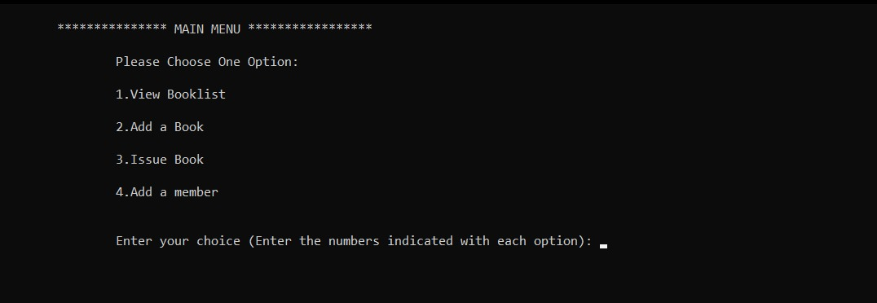

Testing Data

|  |  |  |  |  |
| --- | --- | --- | --- | --- |
| Field | Subfield | Testing Data 1 (Input) | Testing Data 2 | Testing Data 3 |
| Add a Book | Book’s Name | Science | Discrete Math | Rich Dad Poor Dad |
|  | Author’s Name | John Beats | Roger Michael | Robert Kiyosaki |
|  | Publication Name | Selina Publishers | Westland Publication | Warner Books Ed. |
|  | Book ID | 223344 | 435678 | 557766 |
|  | Book’s Price (in CAD) | 66 | 120 | 35 |
|  | Book Quantity | 1 | 3 | 2 |
|  | Book’s Shelf Number | 12 | 6 | 21 |
|  | IF reference Book | Enter 1 | Enter 1 | Enter 1 |
|  | Else | Press any key | Press any key | Press any key |
| Issue Book | Book’s Name | Science | Discrete Math | Rich Dad Poor Dad |
|  | Book ID | 223344 | 435678 | 557766 |
|  | Author Name | John Beats | Roger Michael | Robert Kiyosaki |
|  | Member Name | Steve | George | Liza |
|  | Member ID | 44556677 | 21213456 | 33442176 |
|  | Enter Data (dd mm yyyy) | 10 03 2021 | 13 03 2021 | 07 03 2021 |
|  | To see suggested book from same author or reference book | Enter 1 | Enter 1 | Enter 1 |
|  | Else | Enter 2 | Enter 2 | Enter 2 |
|  | To see book from same author | Enter 1 | Enter 1 | Enter 1 |
|  | To see reference books | Enter 2 | Enter 2 | Enter 2 |
|  | To go back to main menu | Enter 3 | Enter 3 | Enter 3 |
| Add a Member | Member Name | Steve | George | Liza |
|  | Member ID | 44556677 | 21213456 | 33442176 |
|  | Mobile Number | 9912345687 | 8824619213 | 9424986048 |

User Manual

Kindly Follow the instructions given below to use the Public Library Management System:

* 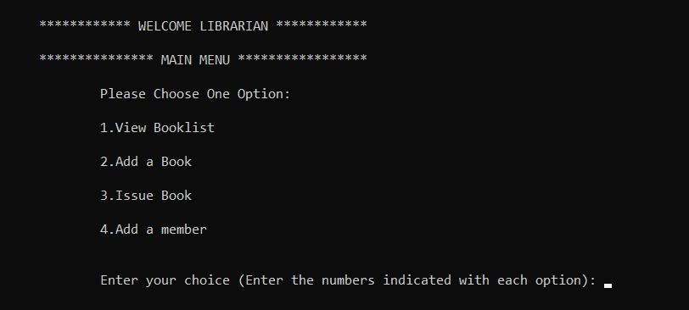The system initiates with a main menu providing four options:
* Now enter your choice
  1. If you want to view the booklist enter 1. This will open the booklist which will only show the books added by the user. Press any key to go back to the main menu. (If no book is added the system will not show any book)
  2. Text

     Description automatically generatedIf you want to Add a Book enter 2. Then the system will ask the following options enter your choice there.
     1. Text

        Description automatically generatedIf you want to add a book enter 1 else enter 2. It will display the following:   
        (Kindly refer to the data in the image as the sample data for adding a book.)

Press any key to go back to main menu.

* 1. Graphical user interface, text, application

     Description automatically generatedIf you want to Issue a Book enter 3. It will display the following:

* + 1. Text

       Description automatically generatedIf you want to issue a book enter 1 else enter 2. (Kindly refer to the data in the image as the sample data for adding a book.)
    2. Graphical user interface, text

       Description automatically generated with medium confidenceNow, enter 1 if you want to see books recommendations from the same author or want to issue a reference book (if available), else enter 2 to go back to main menu.
  1. If you want to add a member enter 4. The following text will be displayed.

References:

Paridhimathur95. (2021). SDLC. Retrieved from https://www.coursehero.com/file/43591533/7-SDLCdocx/.